

**MIS309**

**Final project : Mobily DB Security System**

**Academic year-2023**

**Instructor: MS. Reem Alhumaidan**

**Section: 228**

**Group:2**

|  |  |
| --- | --- |
| Ghada Almutairi | 2210006230 |
| Ghada Aljabari | 2210004618 |
| Wadha Alkhaldi | 2210002465 |
| Norah Alhussain | 2210003016 |
| Ohoud Alshehri | 2210006452 |

Table of Contents

**1-Abstract:** 3

**2-ER Diagram:** 4

**3-PK and FK planning Diagram:** 5

**4****-Assumptions:** 6

**5-Creating tables in SQL Live:** 7

**6-Data inserts in SQL Live:** 11

**7-Tables:** 14

**8-Conclusion & Recommendations:** 18

**9-****References:** 19

# **1-Abstract:**

Mobily is a telecommunications service provider headquartered in Saudi Arabia. The company was founded in 2004 and disrupted Saudi Telecom's monopoly in the wireless industry by launching its mobile services. The company has grown to become one of the leading providers of mobile services in the region (Mobily, 2022). We chose Mobily because it is widely used in Saudi Arabia by individuals, businesses, and organizations. And our aim is to improve and simplify the services to meet the needs of all users. However, Mobily has been reported to be working on intercepting encrypted data sent over the internet by various apps, which has raised concerns over data security. To address this issue, we intend to implement a range of data security measures, including the use of firewalls, data encryption, data masking, as well as data loss prevention software. To visualize this strategy, an entity relationship diagram was created to show the relationships between the various data security measures and how they work together to safeguard customer data. By implementing these measures, Mobily aims to enhance its data security and maintain the trust of its customers.

# **2-ER Diagram:**

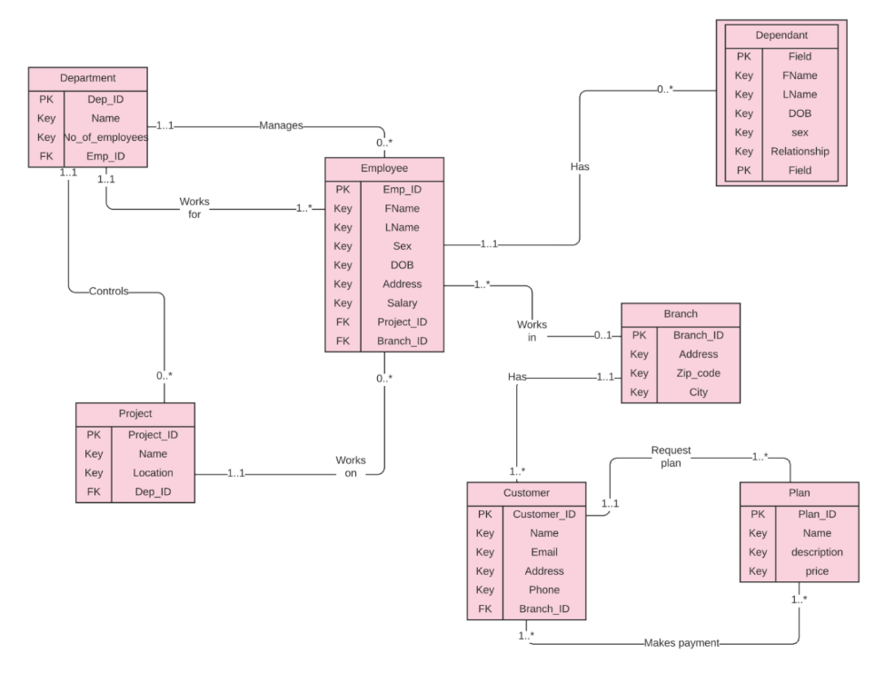

# **3-PK and FK planning Diagram:**

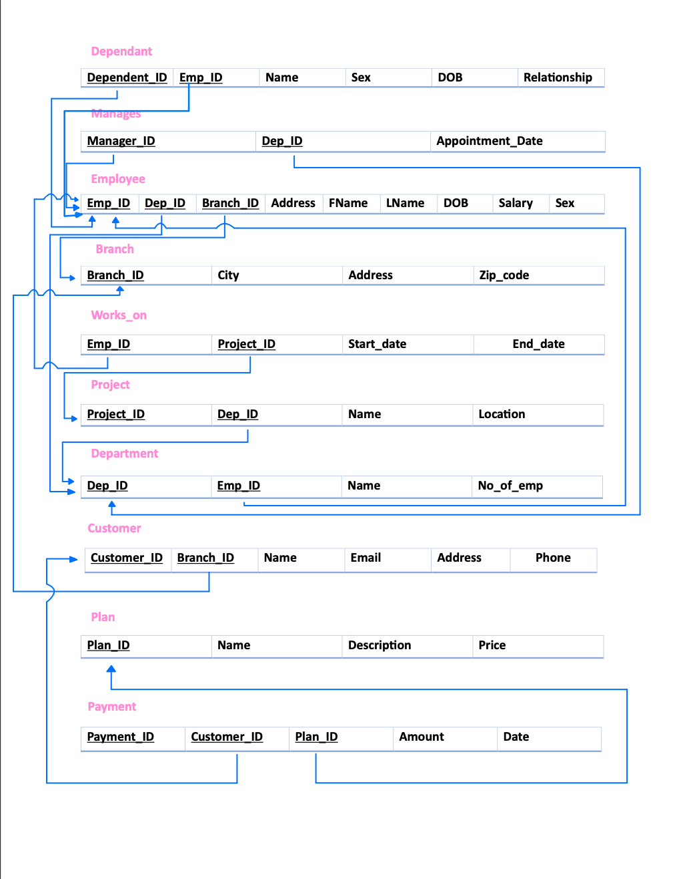

# **4-Assumptions:**

* Each department is managed by one employee who is the manager but not all employees are managers (one to many).
* Each department controls various projects, and a project is controlled by one department (one to many).
* Each department has a number of employees, and an employee works for one department (one to many).
* Each employee may work on several projects besides some employees don’t work on any project, and each project is performed by one employee (one to many).
* Each employee may have several dependants, and a dependant is associated to one employee (one to many).
* Number of employees work in a branch, and a branch has several employees (one to many).
* Each branch has various customers, but each customer associates with one branch (one to many).
* Each customer may request many plans, and each plan belongs to a customer (one to many).
* Many customers have many plan payments (many to many).

# **5-Creating tables in SQL Live:**

**-Department table:**

CREATE TABLE department (

department_id NUMBER PRIMARY KEY,

department_name VARCHAR2(50) NOT NULL,

num_of_employees NUMBER

);

**-Project table:**

CREATE TABLE project (

project_id NUMBER PRIMARY KEY,

project_name VARCHAR2(50) NOT NULL,

project_Location VARCHAR2(50) NOT NULL,

department_id NUMBER,

FOREIGN KEY (department_id) REFERENCES department(department_id)

);

**-Employee table:**

CREATE TABLE employee (

employee_id NUMBER PRIMARY KEY,

first_name VARCHAR2(50) NOT NULL,

last_name VARCHAR2(50) NOT NULL,

seconed_name VARCHAR2(50) NOT NULL,

address VARCHAR2(100),

job_title VARCHAR2(20),

department VARCHAR2(50),

sex VARCHAR2(10),

salary NUMBER,

department_id NUMBER,

FOREIGN KEY (department_id) REFERENCES department(department_id)

);

**-Branch table:**

CREATE TABLE branch (

branch_id NUMBER PRIMARY KEY,

branch_name VARCHAR2(50) NOT NULL,

city VARCHAR2(50),

zipcode VARCHAR2(50)

);

**-Dependent table:**

CREATE TABLE dependent (

dependent_id NUMBER PRIMARY KEY,

first_name VARCHAR2(50) NOT NULL,

seconed_name VARCHAR2(50),

last_name VARCHAR2(50) NOT NULL,

relationship VARCHAR2(50),

employee_id NUMBER,

FOREIGN KEY (employee_id) REFERENCES employee(employee_id)

);

**-Works_on table:**

CREATE TABLE works_on (

employee_id NUMBER NOT NULL,

project_id NUMBER NOT NULL,

start_date VARCHAR(50) NOT NULL,

end_date VARCHAR(50) NOT NULL,

PRIMARY KEY (employee_id, project_id),

FOREIGN KEY (employee_id) REFERENCES employee (employee_id),

FOREIGN KEY (project_id) REFERENCES project (project_id)

);

**-Manages table:**

CREATE TABLE manages (

manager_id INT NOT NULL,

department_id INT NOT NULL,

appointment_date VARCHAR(50),

PRIMARY KEY (manager_id, department_id),

FOREIGN KEY (manager_id) REFERENCES employee (employee_id),

FOREIGN KEY (department_id) REFERENCES department (department_id)

);

**-Customer table:**

CREATE TABLE Customer (

customer_id NUMBER PRIMARY KEY,

name VARCHAR(50),

email VARCHAR(50),

phone VARCHAR(20),

address VARCHAR(100),

branch_id NUMBER ,

FOREIGN KEY (branch_id) REFERENCES branch(branch_id)

);

**-Plan table:**

CREATE TABLE Plan (

plan_id NUMBER PRIMARY KEY,

name VARCHAR(50),

description VARCHAR(100),

price DECIMAL(10, 2),

customer_id NUMBER ,

FOREIGN KEY (customer_id) REFERENCES Customer(customer_id)

);

**-Payment table:**

CREATE TABLE Payment (

payment_id INT PRIMARY KEY,

amount DECIMAL(10, 2),

payment_date VARCHAR(50),

customer_id NUMBER ,

service_id INT,

FOREIGN KEY (customer_id) REFERENCES Customer(customer_id)

);

# **6-Data inserts in SQL Live:**

**-Department table inserts:**

INSERT INTO department VALUES (1, 'IT', 10);

INSERT INTO department VALUES (2, 'Marketing', 12);

INSERT INTO department VALUES(3, 'Human Resources', 10);

INSERT INTO department VALUES(4, 'Finance', 6);

**-Project table inserts:**

INSERT INTO project VALUES (1, 'Data Encryption', 'Dammam', 01);

INSERT INTO project VALUES (2, 'Firewall', 'Riyadh', 02);

INSERT INTO project VALUES (3, 'Data Masking', 'Jeddah', 03);

INSERT INTO project VALUES (4, 'Data Loss Prevention Software', 'Dammam', 04);

**-Employee table inserts:**

INSERT INTO employee VALUES (1, 'John', 'Doe', 'Shon', 'Eastern province-Alhamra-117', 'Software Engineer', 'IT', 'M', 80000, 1);

INSERT INTO employee VALUES (2, 'Mary', 'Smith', 'Joy', 'Western province-Aljawharah-522', 'Marketing Manager', 'Marketing', 'F', 100000, 2);

INSERT INTO employee VALUES (3, 'Ahmed', 'Khalil', 'Ali', 'Riyadh-Alyassmin-115', 'HR Specialist', 'Human Resources', 'M', 60000, 3);

INSERT INTO employee VALUES (4, 'Sara', 'Al-Mutairi', 'Hamad', 'Eastern province-Alrabiya-234', 'Financial Analyst', 'Finance', 'F', 75000, 4);

**-Branch table inserts:**

INSERT INTO branch VALUES (121, 'Dammam', 'Eastern province-Almanar-334', '32221-354');

INSERT INTO branch VALUES (122, 'Riyadh', 'center-Almalga-569', '32287-556');

INSERT INTO branch VALUES (123, 'Jeddah', 'western province-Aldurrah-528', '34425-896');

INSERT INTO branch VALUES (124, 'Yanbu', 'Madinah Region-AlShati-588', '2603-305');

**-Dependent table inserts:**

INSERT INTO dependent VALUES (11, 'Joe', NULL, 'Doe', 'Son', 1);

INSERT INTO dependent VALUES (12, 'Jane', NULL, 'Doe', 'Daughter', 1);

INSERT INTO dependent VALUES (13, 'Mike', NULL, 'Smith', 'Son', 2);

INSERT INTO dependent VALUES (14, 'Sara', NULL, 'Khalil', 'Daughter', 4);

**-Works_on table inserts:**

INSERT INTO works_on VALUES (1, 1, '2020-11-11', '2022-02-01');

INSERT INTO works_on VALUES (2, 2, '2023-01-01', '2022-03-01');

INSERT INTO works_on VALUES (3, 3, '2022-02-01', '2022-03-01');

INSERT INTO works_on VALUES (4, 4, '2020-11-02', '2021-11-02');

**-Manages table inserts:**

INSERT INTO manages VALUES (01, 1, '2022-01-01');

INSERT INTO manages VALUES (02, 2, '2022-01-01');

INSERT INTO manages VALUES (03, 3, '2022-02-01');

INSERT INTO manages VALUES (04, 1, '2022-03-01');

**-Customer table inserts:**

INSERT INTO Customer VALUES (1001,'John Smith', 'john.smith@example.com', '555-1234', 'Eastern province-Alnuzha-122', 121);

INSERT INTO Customer VALUES (1002, 'Jane Doe', 'jane.doe@example.com', '555-5678', 'Riyadh-Alhamra-119',122);

INSERT INTO Customer VALUES (1003, 'Bob Johnson', 'bob.johnson@example.com', '555-9012', 'Madinah Region-Alsheera-754', 123);

INSERT INTO Customer VALUES (1004, 'Sara Saleh', 'sara.saleh@example.com', '555-3456', 'Western province-Albalad-864', 124);

**-Plan table inserts:**

INSERT INTO Plan VALUES (1, 'Basic Plan', 'Includes basic features', 19.99, 1001);

INSERT INTO Plan VALUES (2, 'Premium Plan', 'Includes premium features', 29.99, 1002);

INSERT INTO Plan VALUES (3, 'Business Plan', 'Includes business features', 49.99, 1003);

INSERT INTO Plan VALUES (4, 'Enterprise Plan', 'Includes enterprise features', 99.99, 1004);

**-Payment table inserts:**

INSERT INTO Payment VALUES (1, 19.99, '2022-01-01', 1001, 1);

INSERT INTO Payment VALUES (2, 29.99, '2022-02-01', 1002, 2);

INSERT INTO Payment VALUES (3, 49.99, '2022-03-01', 1003, 3);

INSERT INTO Payment VALUES (4, 99.99, '2022-04-01', 1004, 4);

# **7-Tables:**

**Department table**:

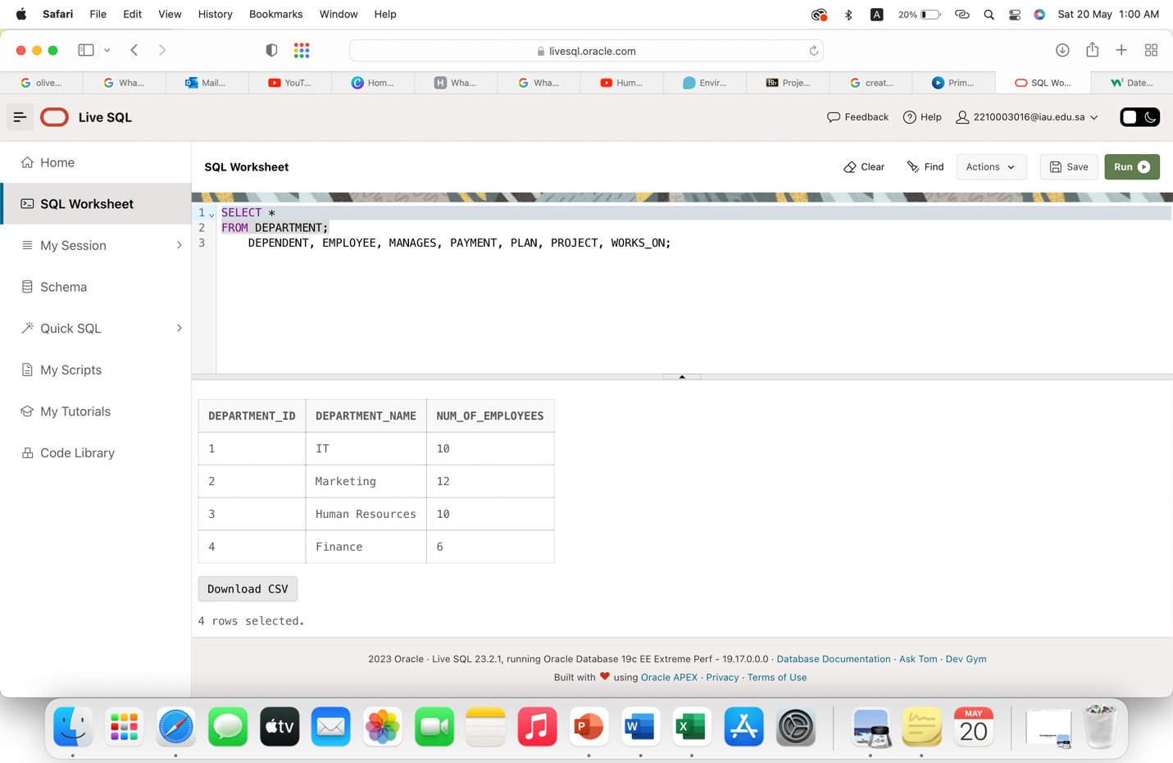

**Project table:**

**Employee table:**

**Branch table:**

**Dependent table:**

**Works_on table:**

**Manages table:**

**Customer table:**

**Plan table:**

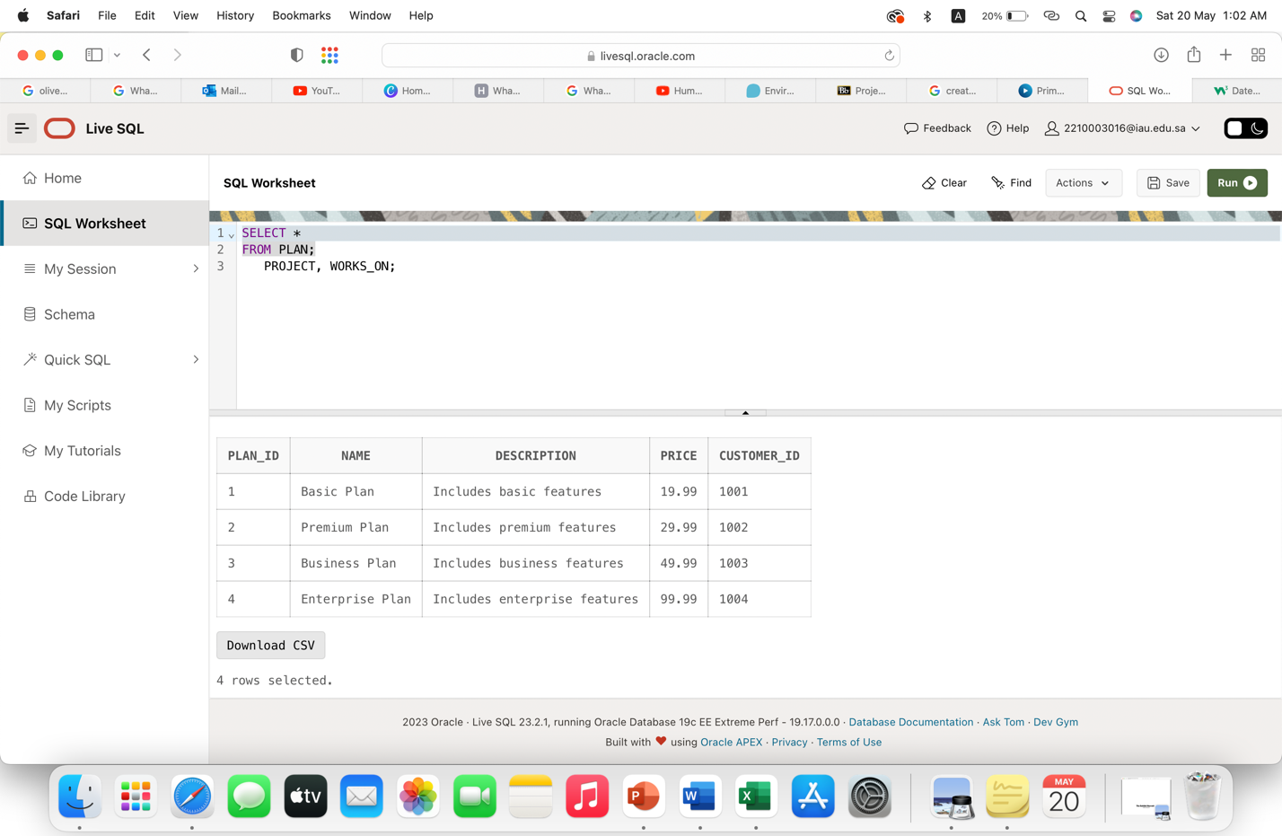

**Payment table:**

# **8-Conclusion & Recommendations:**

As a company that handles sensitive information such as user data and communication records, Mobily understands the importance of data security and needs to implement robust security measures to protect its data from unauthorized access and theft. So, in this project we have been developing firewalls for Mobily to block unauthorized access to its network and data encryption to secure all transmitted data, ensuring that it cannot be intercepted by hackers.

To enhance the protection of sensitive data from unauthorized access, we have implemented upgraded data masking techniques to anonymize the data. This method makes it difficult for anyone without authorized access to gain entry to sensitive information. Additionally, we added data loss prevention software to identify and prevent unauthorized data access and transmission. Mobily's commitment to robust data security measures demonstrates its dedication to protecting the privacy and security of the data it handles, which is essential in building and maintaining trust with its customers.

In order to prevent possible financial losses, legal responsibilities, and harm to its reputation, we recommend Mobily prioritize the security of its data. We also recommend Mobily keep up with the latest security threats by regularly evaluating and improving its security protocols. We also suggest that the company provide security awareness training to its employees to ensure that they are aware of potential security risks and take appropriate precautions to protect sensitive data.

# **9-References:**

Mobily, C., 2022. *Overview.* [Online]   
Available at: https://www.mobily.com.sa/wps/portal/web/personal/am-overview/overview  
[Accessed 16 April 2023].

Connolly, T.M. and Begg, C.E. (2020) *Database systems: A practical approach to design, implementation and management*. Uttar Pradesh, India: Pearson India Education Services.

**Contributions:**

|  |  |
| --- | --- |
| Ghada Almutairi | ERD,  PK and FK planning diagram,  “Branch” SQL statement and inserts |
| Ghada Aljabari | Abstract |
| Wadha Alkhaldi |  |
| Norah Alhussain | Creating tables and inserts in SQL live |
| Ohoud Alshehri | Conclusion and Recommendations |